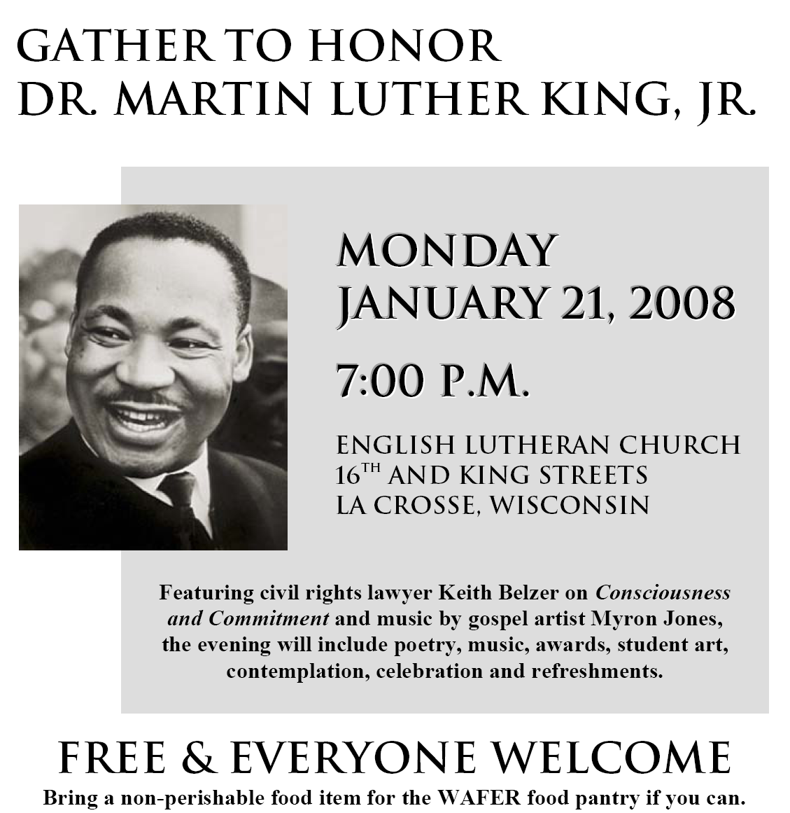
“I have the audacity to believe that peoples everywhere can have three meals a day for their bodies, education and culture for their minds, and dignity, equality and freedom for their spirits. I believe that what self-centered men have torn down, men other-centered can build up. ... I still believe that we shall overcome.” - Nobel Prize acceptance speech, December 10, 1964
Co-sponsors: AmeriCorps, English Lutheran Church, Franciscan-Skemp Foundation, Gundersen Lutheran Medical Foundation, Coulee Progressives, Jubilee Center for Justice and Peace, La Crosse Interfaith Justice and Peace Coalition, Onalaska United Methodist Church, NAACP- La Crosse, UW-La Crosse, YWCA, Western Technical College. For more information, please call 608 782-1394 or 608 784-9335.

